NUCLEAR ENERGY

A Project Report Submitted
in Partial Fulfilment of the Requirements
for the Degree of
BACHELOR OF TECHNOLOGY
in
Mechanical Engineering
By

Tanishq Maurya (Univ. no. 2210013105036)

Under the Guidance of
Dr. Praveen Kumar Rai

FACULTY OF ENGINEERING AND TECHNOLOGY,
UNIVERSITY OF LUCKNOW, LUCKNOW
2024 – 25

DECLARATION
I hereby declare that this submission is my own work and that, to the best of our knowledge and belief, material which to a substantial extent has been accepted for the award of any other degree or diploma of the University or other institute of higher education, except where due acknowledgement has been made in the text.

Signature
Student Name: TANISHQ MAURYA
(Univ. Roll. No.): 2210013105036
Date: 3rd May 2025

CERTIFICATE
This is to Certify that Tanishq Maurya (2210013105036) has carried out the Seminar work presented in this Seminar report entitled “NUCLEAR ENERGY” for the award of Bachelor of Technology (Mechanical Engineering) from Faculty of Engineering and Technology, University of Lucknow, Lucknow under my/our guidance. And, the Seminar report the contents of the project report do not form the basis for the award of any other degree to the candidate or to anybody else from this or any other University/Institution.

Signature
(Name of Guide)
(Designation)

ACKNOWLEDGEMENTS
I would like to express my sincere gratitude to Dr. Praveen Kumar Rai for their invaluable guidance and support in completion of the report. Dr. Praveen Kumar Rai provided mentorship and their insights and expertise, which instrumental in successful completion of the Seminar report titled: “NUCLEAR ENERGY”
We would like to express our sincere thanks for your time and efforts involved without which this would not be possible. We would also like to extend our special thanks to the University for providing us this monumental opportunity to collaborate and build this report.

TABLE OF CONTENTS

Declaration
Certificate
Acknowledgements
List of Figures
CHAPTER 1: INTRODUCTION
- GENERAL
- RADIOACTIVITY
- DISCOVERY
    - URANIUM
CHAPTER 2: LITERATURE REVIEW
- INTRODUCTION
- BINDING ENERGY
- FISSION EQUATION
- APLHA DECAY
- BETA DECAY
- GAMMA DECAY
CHAPTER 3: COMPONENTS OF A NUCLEAR REACTOR
- INTRODUCTION
- FUEL RODS
- CONTROL RODS
- NEUTRON MEDIATOR
- COOLANT
- REFLECTOR
- SHIELDING
Page no.
ii
iii
iv
v
vi
1-3

4-6

7-8

CHAPTER 4: OPERATION
- INTRODUCTION
- POWERING REACTOR
- CONTROL
- REMOVING DEPLETED FUEL
CHAPTER 5: HAZARDS OF NUCLEAR ENERGY
- INTRODUCTION
- NUCLEAR MELTDOWN
- NUCLEAR WASTE DISPOSAL
- PROTOCOLS AND CHECKS
- CERNOBYL DISASTER
- 3 MILE ISLAND DISASTER
- FUKUSHIMA DISASTER
References
CURRICULUM VITAE

9-10

11-14

LIST OF FIGURES

CHAPTER 1
INTRODUCTION

Nuclear Energy is one of the cleanest and most controversial form energy in the history of man-kind. It is highly underutilized source of energy considering its abundant nature. It is often seen as key to solve our increasing energy needs and a fuel for sustainable future.

1.1 GENRAL
Nuclear Energy is categorized into two nuclear fusion and nuclear fission. We primarily produce nuclear energy in the fission form, the energy produced by a fission chain reaction. The element that can undergo fission through neutron capture, are known as fissile.
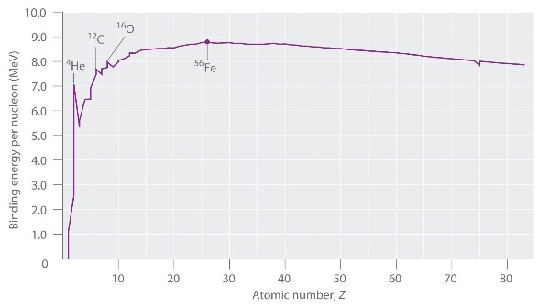
At the far end of the stability curve lies U-235 isotope
1.3 DISCOVERY
- Radioactivity was accidently discovered by Henri Becquerel in 1896, when he was using naturally fluorescent minerals to study the properties of X-rays, he exposed potassium uranyl sulfate to sunlight and then placed it on photographic plates wrapped in black paper, believing that the uranium absorbed the sun’s energy and then emitted it as x-rays. A hypothesis which was later corrected by him.
- MARIE CURIE: The term radioactivity was actually coined by Marie Curie, who together with her husband Pierre, began investigating the phenomenon recently discovered by Becquerel. On observing leftover ore, it was found that it was more radioactive than the pure uranium. It was later found that the Uranium ore consists or more radioactive elements such as polonium and radium.
Uranium-235 is the mostly widely used nuclear fuels. Since, it is naturally abundant compared to its lab synthesized counterparts like plutonium or thorium.
1 mol of Uranium undergoing nuclear fission releases about
E = 1.8 x 10¹⁰ KJ
Which is sufficient to power a household for a lifetime or even power a small town for months.
Nuclear fuel is clean fuel and does not directly impact environment. Negative externalities, however still exists but they are limited in number compared to its numerous advantages over other carbon-based fuels.
One, 5g of enriched Uranium-235 pallet produces energy equals to 565 liters of crude oil, 1-tonne of coal or 480cm3 of natural gas on combustion. The estimated cost (Minning, transportation, storage etc.) of them is significantly larger that its equivalent in Uranium. 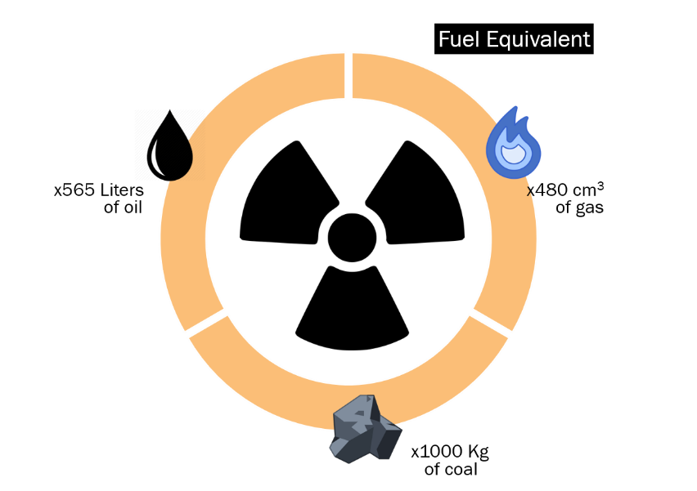

1.3.1 URANIUM
There are three natural isotopes of uranium — uranium-234 (U-234), uranium-235 (U-235) and uranium-238 (U-238). U-238 is the most common one, accounting for around 99 per cent of natural uranium found on earth. Most nuclear reactors use fuels containing U235, however, natural uranium typically contains only 0.72 per cent of U-235 There are in total about 422 operational fission reactors in the world (source IAEA) from which more than 99% are Uranium reactors. Uranium-238 is another isotope of uranium that is used laboratory production of plutonium.
Uranium cannot be used directly in its natural form. U-235 isotopes are present with other Uranium isotopes and once mined it needs to processed in order use it, it must be purified from its ore, Uranium is first milled in a ‘Yellow cake’ form, the ‘Yellow cake’ is converted into uranium oxide and then into uranium fluoride which is then enriched. The enriched Uranium fluoride is then converted back in uranium oxide, to be in turn converted into uranium pallets for its usage as a nuclear fuel.

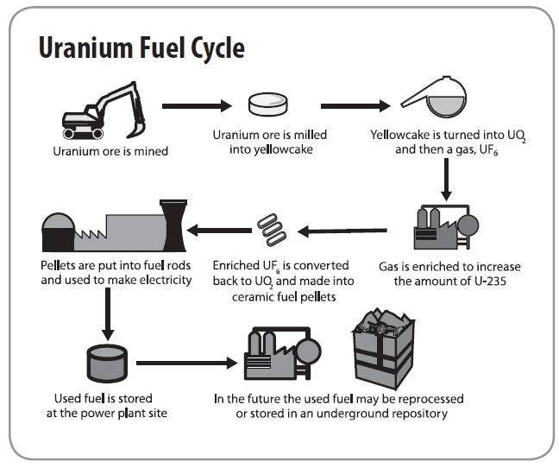

CHAPTER 2
LITERATURE REVIEW

Let us review our fundamental understanding of Nuclear Chemistry, and mass-energy equivalence, to obtain a basic understanding of the topic.

2.1 INTRODUCTION
Nuclear reactions are based on nuclear kinetics. As with chemical reactions, the nuclear reactions are not instantaneous and evolve on differing times. The stability of a nucleus depends upon the constituent neutrons and protons. Increasing number of neutron and protons results in an unstable nucleus.
The stability curve of nucleus is given below. 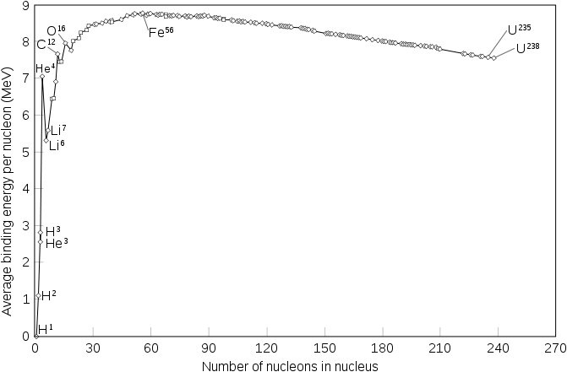

2.2 BINDING ERERGY
“The energy required to disperse or separate particle in a system is known as binding energy”. Nuclear binding energy is the energy required to break a nucleus into its constituent protons and neutrons.
One the break throughs of the Quantum mechanics is the mass energy equivalence. It states that ‘Energy is equals to mass when the velocity of body tends to be equal speed of light’.
E = mc²
From observing the mass of nucleus which has undergone nuclear fission or even nuclear decay, we reached an interesting conclusion, that the combined mass of the daughter nuclei is significantly less that the mass of parent nucleus. A phenomenon commonly known as a Mass defect.
We determined that the difference in masses of the nuclei is equals to the Binding energy released during the process. Energy which is needed for fission of the two nuclides.
following the equation,
E=mc².
B.E=Δmc²
Δm = E/c²

2.3 FISSION EQUATIONS
Half-life of a radioactive element is defined ’as the time frame in which a unit radioactive nuclear mass is decayed or reduced into half its original mass’. It is given by equation,
N= N₀e^{-λt}
-λt=$ln⁡|2|$
where,
t is time λ is disintegration or decay const.
N is number of particles undergoing decay.
N0 is number of particles left after decay.
It is also known as decay equation.
{Halflife Graph}
Nuclear Decay
2.3.1 ALPHA DECAY
α-decay is a type of radioactive decay in which an atomic nucleus emits an alpha particle (helium nucleus). The parent nucleus transforms or "decays" into a daughter product, with a mass number that is reduced by four and an atomic number that is reduced by two.
An alpha particle is identical to the nucleus of a helium-4 atom, which consists of two protons and two neutrons. It has a charge of +2 e and a mass of 4 Da.
For example, uranium-238 decays to form thorium-234. Alpha decay typically occurs in the heaviest nuclides. Theoretically, it can occur only in nuclei somewhat heavier than nickel (element 28), where the overall binding energy per nucleon is no longer a maximum and the nuclides are therefore unstable toward spontaneous fission-type processes.
$${}_{92}^{238}U→{}_{4}^{2}He+{}_{90}^{234}Th$$
2.3.2 BETA DECAY
β-decay is a type of radioactive decay in which an atomic nucleus emits a beta particle (fast energetic electron or positron), transforming into an isobar of that nuclide.
For example, beta decay of a neutron transforms it into a proton by the emission of an electron accompanied by an antineutrino; or, conversely a proton is converted into a neutron by the emission of a positron with a neutrino in what is called positron emission (positron - electron anti particle).
β-decay is of two types,
- β+ decay (beta positive decay):
The beta decay in which a proton in an unstable nucleus transforms into a neutron while emitting a positron (e+) is known as beta negative decay. An example is Nitogen-13.
${}_{7}^{13}N→ {}_{6}^{13}C+e^{+}+ν$
- β- decay or (beta negative decay):
The beta decay in which a neutron in an unstable nucleus transforms into a proton while emitting an electron is known as beta negative decay. An example is tritium.
$${}_{1}^{3}H→_{2}^{3}He+e^{- }+\overline{ν}$$
2.3.3 GAMMA DECAY
Gamma decay is a type of radioactive decay where an unstable atomic nucleus releases energy in the form of gamma rays, which are high-energy electromagnetic radiation. Gamma decay does not involve any release of charged particle, instead produces gamma rays as nucleus transitions to a lower energy level.
For example, gamma decay of Barium-137 in which the level of energy lowers. The element Barium-137 loses its spin as well as dissipates its energy and becomes stable from its unstable state.
$${}_{56}^{137}Ba→{}_{56}^{137}Ba++{}_{0}^{0}ϒ$$

CHAPTER 3
COMPONENTS OF A NUCLEAR REACTOR

A nuclear powerplant is very similar to a thermal powerplant with a few notable differences, a nuclear reactor uses nuclear fission to produce thermal energy, to produce steam in comparison to standard thermal powerplants that uses fossil fuels .

3.1 INTRODUCTION
A nuclear powerplant consists of a Nuclear Reactor as steam generator (in place of a boiler), a turbine unit for producing electricity from steam, a heat exchanger- Condenser, Cooling towers, reservoir etc., and pumps cooled to transport water back to reactor. Apart from, the reactor is housed by heavy infrastructure made of tons of Concrete, Lead and Steel layering to seal the radiation. The containment building is the last of several safeguards that prevent the release of radioactivity to the environment. Many commercial reactors are contained within a 1.2-to-2.4-metre (3.9 to 7.9 ft) thick pre-stressed, steel-reinforced, air-tight concrete structure that can withstand hurricane-force winds and severe earthquakes.

3.2 FUEL RODS
They are the containment vessel that houses the fuel element. Nuclear fuel is a material capable of fissioning sufficiently to reach critical mass, that is, to sustain a nuclear chain reaction. It is placed in such a way that the thermal energy produced by this nuclear reaction can be rapidly extracted. For a nuclear reactor to operate for a period of time, it must have excess reactivity, which is maximum with fresh fuel and decreases with its life until it is eliminated. At this moment the recharging of the nuclear fuel is carried out.
3.3 CONTROL RODS
Control rod bundles provide a rapid means of controlling chain reactions. These bars allow for rapid power changes in the nuclear reactor and its eventual shutdown in case of emergency. Control rods are made of neutron absorbing materials and typically have the same dimensions as the fuel elements. In normal operation, a nuclear reactor has the control rods fully or partially removed from the core. The core's reactivity coefficient is increased or decreased by raising or lowering the control rods. Raising or lowering the control rods changes the amount of neutron-absorbing material contained in them in the core.
3.4 NEUTRON MEDATORS
Neutrons resulting from a nuclear fission reaction have high kinetic energy. The higher their speed, the less likely they are to fission other atoms, so it is advisable to reduce this speed to encourage new chain reactions.
The function of the moderator is to reduce the kinetic energy of the neutrons through elastic collisions of the neutrons with the nuclei of the moderator itself. Among the most used moderators are light water, heavy water and graphite.
3.5 COOLANT
The function of the coolant is to absorb this thermal energy and transport it. The coolant must be anti-corrosive, with a high heat capacity and must not absorb neutrons.
3.6 REFLECTOR
The function of the coolant is to absorb this thermal energy and transport it. The coolant must be anti-corrosive, with a high heat capacity and must not absorb neutrons.
3.7 SHIELDING
When a nuclear reactor is in operation, a large amount of radiation is generated . Shielding is used to protect and isolate the facility's workers from the radioactivity caused by fission products. The most commonly used materials to build this shielding are concrete, water and lead.
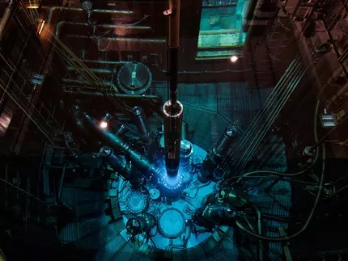

CHAPTER 4
OPERATION
Nuclear power plant operates under surveillance and undergoes extreme monitoring and inspection due to risks associated with nuclear energy. A nuclear reactor converts nuclear energy into thermal energy, to be produced into electrical energy.

4.1 INTRODUCTION
A neutron collides with a Uranium-235 atom. This extra neutron creates unstable Uranium-236 isotopes, which split almost instantly. This splitting produces heat, which produces high pressured steam driving the turbine.
4.2 POWERING REACTOR
A nuclear chain reaction is required to start a nuclear reactor.This is caused by a startup neutron source, such as Californium-252 or Plutonium-238. These metallic elements are inserted into the reactor with new nuclear fuel. As control rods are lifted from the reactor core, neutrons from the neutron source start to fire, and because there is enough fuel for a sustained reaction, we start the fission process, which sustains a plant for an entire 18 to 24 months of operation.
4.3 CONTROLING CHAIN REACTION
The rate of a nuclear chain reaction is controlled by the control rods which absorbs excess neutron produced during the chain reaction. The rate of reaction can be increased or decreased by inserting or removing the control rods. The reactor generally operates in critical state, (i.e a nuclear chain reaction is self-sustaining—that is, when reactivity is zero.) In supercritical states, if the coefficient of
4.4 REMOVING DEPLETED FUEL
Depleted fuel is removed from the fuel rods once all fuel is used up. Although all the byproducts of the reaction is less radioactive than pure uranium it is still highly radioactive. The depleted fuels is then repurposed or storage in underground facilities for the purpose of disposal. Where the byproduct undergoes decay for rest of their half-life to form one of the stable Pb isotopes.

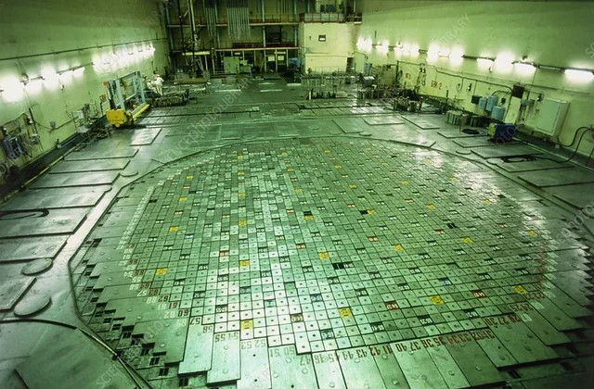

CHAPTER 5
HAZARD OF NUCLEAR ENERGY
Over the years, various accidents have occurred due to improper handling of nuclear fuels, there includes cases of contaminant leakage, complete or partial meltdown, loss of nuclear war heads and incident of nuclear explosion. Nuclear energy has claimed millions of lives due direct exposure to radiation or acute radiation poisoning.

5.1 INTRODUCTION
The nuclear Energy is extremely dangerous. There have been several nuclear accidents over the years, including a nuclear explosion caused due to complete meltdown of fuel element. And two notable partial meltdowns causing the radioactive element being released into the environment.
5.1.1 NUCLEAR MELTDOWN
A Nuclear meltdown is resulted from overheating which causes damage to the core of the reactor. A core meltdown accident occurs when the heat generated by a nuclear reactor exceeds the heat removed by the cooling systems to the point where at least one nuclear fuel element exceeds its melting point A meltdown may be caused by a loss of coolant, loss of coolant pressure, or low coolant flow rate, or be the result of a criticality excursion in which the reactor's power level exceeds its design limits.
A meltdown may be caused by a loss of coolant, loss of coolant pressure, or low coolant flow rate, or be the result of a criticality excursion in which the reactor's power level exceeds its design limits.
5.1.2 NUCLEAR WASTE DISPOSAL
The simplest way would be to put the canisters inside darts with pointed lead-filled nose cones and drop them in the deep ocean, where they would hit the seabed at high speed and bury themselves deep in the silt.
Deep geographical storage, in which, the spent fuel is stripped out of the rods, the high-level wastes are extracted and then turned into a dried powder, which is mixed in with molten glass. This is then poured into stainless steel containers

about 3 feet (1 m) tall and allowed to cool. The end product is almost chemically inert and the radioactive material is dispersed throughout the glass, reducing the amount of radiation emitted.
5.1.3 PROTOCOLS AND CHECKS
The IAEA or the International Atomic Energy Agency is an organization working for increasing nuclear co-operation. It was established prevent nuclear proliferation, has specific roles as the international safeguards inspectorate and as a multilateral channel for transferring peaceful applications of nuclear technology. The IAEA conducts
regular inspection of enrichment sites and nuclear powerplant to check specified nuclear protocols are being followed. 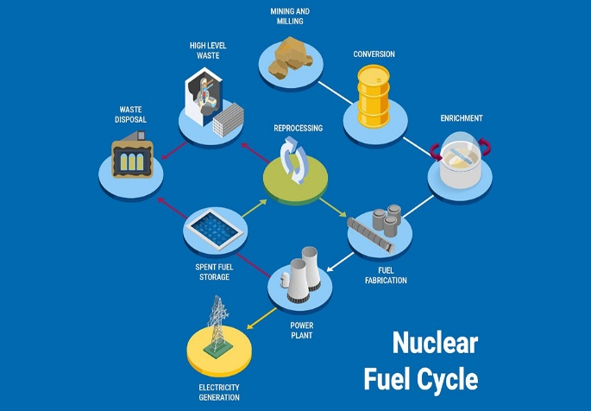

5.2 CERNOBYL DISASTER
On 26 April 1986, the No. 4 reactor of the Chernobyl Nuclear Power Plant, located near Pripyat, Ukrainian SSR, Soviet Union (now Ukraine), exploded. The response involved more than 500,000 personnel and cost an estimated 18 billion rubles (about $84.5 billion USD in 2025). It remains the worst nuclear disaster in history. The disaster occurred while running a test to simulate cooling the reactor during an accident in blackout conditions. The operators carried out the test despite an accidental drop in reactor power, and due to a design issue, attempting to shut down the reactor in those conditions resulted in a dramatic power surge. The reactor components ruptured and lost coolants, and the resulting steam explosions and meltdown destroyed the Reactor building. The disaster occurred while running a test to simulate cooling the reactor during an accident in blackout conditions. The operators carried out the test despite an accidental drop in reactor power, and due to a design issue, attempting to shut down the reactor in those conditions resulted in a dramatic power surge. The reactor components ruptured and lost coolants, and the resulting steam explosions and meltdown destroyed the Reactor building
It had devastating and lasting consequences. Causing the contamination of hundreds of acres of crop land near the eastern Europe border. High levels of radiation were observed in poultry which made them unfit for human consumption which led to elevated rates of cancer and acute radiation syndrome (ARS) millions of deaths over the years, along with genetic disorders in children living in surrounding regions of USSR and eastern Europe. A containment building was made over the years to prevent any further radiation to escape into the environment. Layers of top soil of surrounded town was removed and the element used for the clean-up purpose was sealed and isolated in underground facilities.
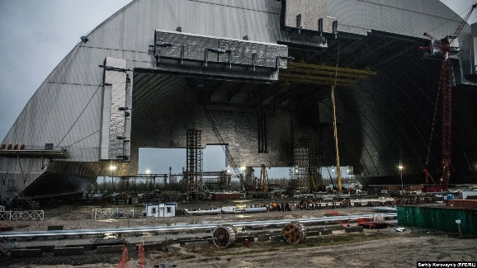
5.3 3 MILE ISLAND DISASTER
The Three Mile Island accident was a partial nuclear meltdown of the reactor of the Three Mile Island Nuclear Generating Station, near Harrisburg, Pennsylvania. It occurred on March 28, 1979, and released radioactive gases and radioactive iodine into the environment. It is the worst accident in U.S. commercial nuclear power plant history. The accident began with failures in the non-nuclear secondary system, followed by a stuck-open pilot-operated relief valve in the primary system, which allowed large amounts of water to escape from the pressurized isolated coolant loop. The mechanical failures were compounded by the initial failure of plant operators to recognize the situation as a loss-of-coolant accident.

5.4 FUKUSHIMA DISASTER
The Fukushima nuclear accident was a major nuclear accident at the Fukushima Daiichi Nuclear Power Plant in Ōkuma, Fukushima, Japan, which began on 11 March 2011. The cause of the accident was the 2011 Tōhoku earthquake and tsunami, which resulted in electrical grid failure and damaged nearly all of the power plant's backup energy sources. The subsequent inability to sufficiently cool reactors after shutdown compromised containment and resulted in the release of radioactive contaminants into the surrounding environment. In addition to atmospheric deposition, there was also a significant quantity of direct releases into groundwater (and eventually the ocean) through leaks of coolant which had been in direct contact with the fuel.
An immediate evacuation zone was constructed which was increased many times. This resulted in many residents having to move multiple times until they reached an area outside of the final 20 km evacuation.

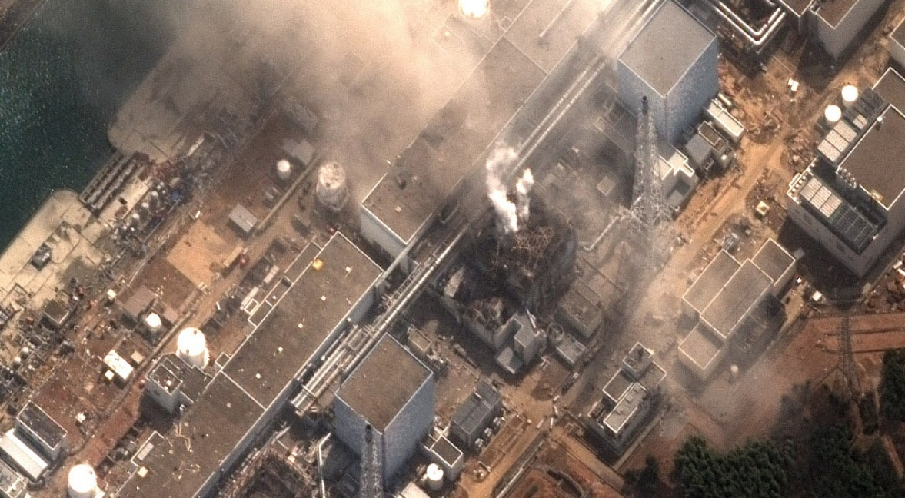

REFRENCES
https://www.wikipedia.org
https://chem.libretexts.org/
https://phys.libretexts.org/
https://www.iaea.org/
https://www.thermal-engineering.org/
https://openstax.org/books/physics/

